PROJECT REPORT

PREDICTIVE MAINTENANCE SYSTEM USING EDGE AI NOISE ANALYSIS

ACKNOWLEDGMENT
The completion of this project and my internship tenure at MRV would not have been possible without the support and guidance. First and foremost, I would like to thank MRV for providing a platform that bridges the gap between academic learning and industrial execution. Having the opportunity to work on cutting-edge engineering systems in a hands-on environment has been an exceptional learning experience.
A special and heartfelt thank you goes to my industry mentors, Dr.Shankar Venugopal [Vice President], Mr.Vinodh, Mr.Senthil Kumar for their continuous guidance, technical insights throughout the duration of this project. Their mentorship was instrumental in helping me navigate complex engineering challenges, from initial algorithm design to practical deployment. Their practical insights into real-world engineering constraints and system deployment were vital to the successful completion of this work.

BASICS OF EV

INTRODUCTION TO EV (Electric Vehicle)

Electric Vehicles use motor for driving the wheels. The energy for the motor is provided by the battery pack present in the vehicle. The battery is charged using an external source through the charging port. Like the automatic cars EV car has 4 modes of driving. The power from battery is sent to a power inverter where it is converted from DC to AC current which is sent to a power electronics controller which provides the required amount of power to the motor according to the acceleration. When the brakes are applied or the speed of the vehicle is reduced, the electric motor provides the power back to the battery pack. This process is called regenrative braking where the motor acts as a generator.
The motor used in EVs are mostly AC powered.

Two components of electric motor:
- Stator - Uses electrical energy to create a rotating magnetic field for the rotor to work (stationary component).

- Rotor - This rotating magnetic field pulls the rotor along with it, forcing it to spin. This spinning motion (torque) turns the vehicle's wheels.

PARTS OF EV (Electric Vehicle)

- Traction Battery Pack
Battery is used as an electricity storage device and provides DC current to the inverter. The initiation or the signal from the controller provides power to motor. Th battery is rechargable and is compactly packed.

- Power Inverter
Converts the DC current from battery to AC current for the usage to motor. Most EVs use bidirectional power inverters which helps to increase efficiency and reduces wastage of power as it helps in providing the power back to the battery when the vehicle is slowed down.

- Electric Traction Motor
The main component of an EV vehicle which power the wheels to rotate from the energy provided by the traction battery pack. Some EVs use motor generators, which helps in the regeneration of the energy when the vehicle slows down. Most commonly used motor in EVs are BLDC (Brushless DC motor) and Permanent Magnet Synchronous Motors (PMSM)

- Power Electronics Controller
The combination of converter and inverter for the supply of current to and from the motor depending upon the speed at which the vehicle is travelling. AC motor systems are used in EV’s for better efficiency.

- Battery (Auxillary)
This battery is used to provide the power for the vehicle accessories such as display screens, audio system, dashcam etc.

- Charger Port
The Channel through which the battery gets charged from an external power supply. Two types of charger are present : On board (in-built charger) and off board (Charger port not present on the vehicle).

- Thermal cooling system and Transmission
System which is used to maintain the temperature of vehicle parts. Transmission converts the electrical energy to mechanical energy and serves as a medium between the controller and wheels.

TYPES OF EVs

- Battery EV (BEV)
Runs entirely on the electricity stored in rechargable traction battery pack. Produce zero emissions and no liquid fuel requirements. Most commonly used batteries for EVs are Lithium Iron Phosphate (LFP) and Nickel Manganese Cobalt (NMC).

- Hybrid EV (HEV)
Consists of both IC engine and electric motors, the mode can be changed and there is no external battery charging. The power for electric motors is provided from the IC engine through the controller.

- Plug-In Hybrid EV (PHEV)
This has the same features of HEV, but has an external charging port.

- Fuel Cell EV (FCEV)
Zero Emission Vehicle, Fuel cell technology is used in these vehicles where the chemical energy is converted to electrical energy.

Vehicle Range depends on the battery power and efficiency. There are three types of charging time :
Slow charging (3kw - 8 to 10 hrs), fast charging (7-22kw - 3 to 4 hrs), rapid charging (43kw - 30 to 60 mins).

Advantages of EV
Environment friendly, less expensive than petrol or diesel vehicles, low maintenance, high quality performance, less noise and charging convenience.

Disadvantages of EV
Number of charging stations, charging time is more depending on the effeciency, limited driving range, high initial cost.

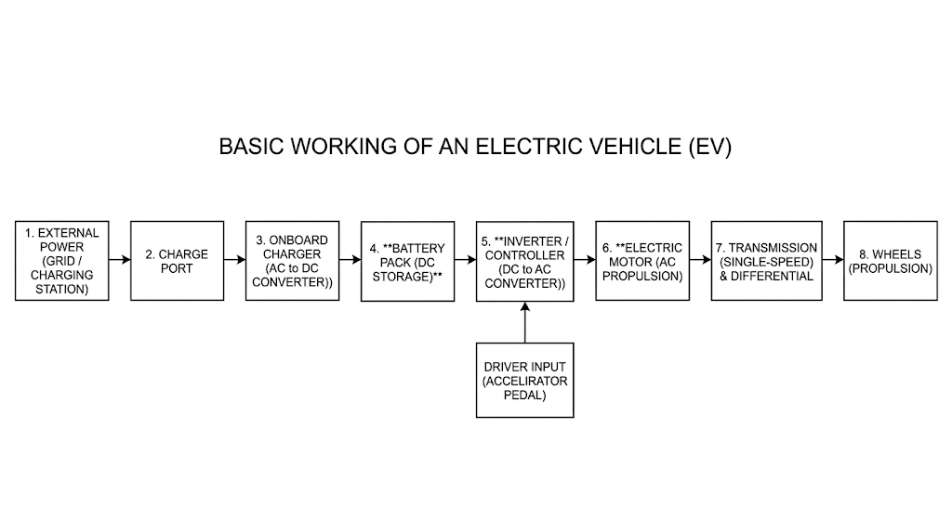

PROBLEM STATEMENT

- Predictive Maintenance System Using Edge-AI Noise Analysis
The Problem: Key components, such as motor , emit abnormal noise right before catastrophic failure. Standard diagnostic systems fail to catch these high-frequency, early-stage noise signals.
The Solution: An Edge-AI "electronic ear" deployed directly onto a resource-constrained microcontroller (such as an ESP32) paired with a digital I2S microphone. By transforming raw time-domain audio streams into frequency-domain spectrograms via digital signal processing, a local, quantized TinyML neural network classifies abnormal noise signal in real time to trigger predictive maintenance alerts before structural failures occur.

Predictive Maintenance System Using Edge-AI Noise Analysis

Objective

To design and build a localized prototype that can accurately listen to the noise created by the drive motors and detect early-stage abnormalities to predict and prevent machine failures before they happen.

Key Assumptions
- It is assumed that the target machinery (motor) emits a distinct, identifiable high-frequency change in its sound spectrum immediately prior to failure.
- The ESP32 microcontroller will have a steady, uninterrupted power supply via USB or an adapter during operation.
- We assume access to both a healthy machine and a faulty machine (or pre-recorded high-quality audio datasets of failures) to properly train the AI model.
- The I2S microphone will be positioned within close structural proximity to the target component to minimize heavy noise during the testing phase.

Idea in Brief
The project deploys a lightweight, compressed Artificial Intelligence model directly onto an ESP32 microcontroller equipped with a digital I2S microphone. The system continuously listens to machine sounds, converts the raw audio into visual frequency maps (time domain to frequency domain) which results in a spectogram, and uses an integrated machine learning model to classify the sound. If an abnormal grinding or sound profile is recognized, the chip instantly triggers a warning (like a buzzer or LED indicator or a notification) to the operators to perform maintenance.

Experimental Approach for PoC (Proof of Concept)
Phase 1 - Audio Data Collection: Connect the I2S microphone (INMP441) to the ESP32 to record distinct, 1-second audio samples of a machine operating normally, operating under a simulated fault (e.g., a recorded friction sound), and general room background noise.
Phase 2 - Signal Processing : Upload the raw audio data to the Edge Impulse studio platform. Apply a Fast Fourier Transform (FFT) block to translate the time-domain sound signals into frequency spectrograms, making the high-frequency failure points visually distinct.
Phase 3 - Model Architecture & Training: Train a simplified Neural Network classifier on the spectrogram imagery. Apply 8-bit quantization to shrink the trained model size down to a fraction of its original size so it can safely fit within the ESP32’s limited RAM.
Phase 4 - Hardware Integration & Deployment: Export the optimized model as an Arduino library. Flash the code onto the physical ESP32 chip alongside the peripheral logic code for the hardware warning indicators. Test the live setup by playing abnormal sounds to verify that the LED or buzzer or notification trigger accurately in real-time.

Deliverables by the End of the Project
- Functional Hardware Prototype: A fully wired breadboard circuit combining the ESP32 microcontroller, digital I2S microphone (INMP441), and emergency warning hardware (LED/Buzzer).
- Trained AI Model: An optimized, functional TinyML classifier deployed locally inside the microcontroller's flash memory.
- Source Code: A full Arduino IDE program including the I2S microphone stream configuration and conditional classification logic.
- Performance Evaluation Report: A brief document showcasing the model’s classification accuracy scores and real-time response latency.

Model Training and Testing
Method 1: MATLAB
1.Data acquisition and Preprocessing
The initial phase of the MATLAB implementation is focused on transforming raw acoustic data into standardized audio formats suitable for frequency analysis. The dataset for acoustic emission was taken from Kaggle - SBUF v1.0 Dataset - Bearing fault data which is an open source dataset.
The acoustic outputs were originally formatted as raw .csv files containing three categories - Normal, inner race fault and outer race fault. These .csv files are converted to .wav files for the efficient training of the model. A folder EV_Acoustic_Simulation is created under which two sub folders are created - Raw_CSV_Data and Raw_Audio. There are two different categories under each subfolders - fault and normal. From the main dataset some amount (for eg. 1000 files) of .csv files are taken and placed in the Raw_CSV_Data folder under both categories. Convert_data.m matlab file contains the code that convert the .csv files into .wav and store it in Raw_Audio folder under the two categories.
(i) Auto-Detection and Extraction
Raw sensor data files frequently vary in their structuring, including variables such as timestamps. To prevent matrix dimension errors during batch processing, the detectImportOptions function was utilized to pre-scan the file . The data was then passed through a conditional logic block that determined the matrix size; if the array contained multiple columns, the script strictly isolated Column 2 (the acoustic vector), while falling back to Column 1 for single-vector files. This ensured efficient extraction without manual dataset auditing.
- Amplitude Normalization
A critical requirement for .wav audio encoding is that amplitude values must be bounded between -1.0 and +1.0. Values exceeding this range result in digital clipping, which destroys the high-frequency mechanical signatures required for fault detection. To prevent this, a mathematical normalization step was introduced. The algorithm identifies the maximum absolute peak within the isolated sensor array and divides the entire vector by this scalar value. This operation scales the highest peak exactly to the 1.0 boundary, proportionally preserving the waveform geometry and harmonic relationships of the motor sound.
(iii) Automated Batch Encoding
Following extraction and normalization, the refined arrays were converted into playable audio files using the audiowrite function. The sample rate was hardcoded to 10,000 Hz to accurately reflect the physical sensor's data collection rate. The loop architecture automatically mapped the processed files from their respective raw directories into structured Normal and Fault output folders, establishing a clean, balanced dataset ready for Mel-Spectrogram feature extraction.
2. Mel-Filterbank Feature Extraction and Dataset Formatting Pipeline
The second phase of the MATLAB implementation involved transforming the preprocessed 1D acoustic time-series waveforms into optimized 2D time-frequency representations (Spectrograms). This transformation allows the system to utilize 2D Neural Network architectures for pattern recognition. The execution script (main_pipeline.m) automated this translation by applying a nonlinear acoustic filterbank and enforcing pixel-level cropping through three steps:
(i) Graphical Rendering and Canvas Optimization
To bypass the processing latency of standard graphical user interface generation, the pipeline was engineered as an execution engine using figure('Visible', 'off'). The graphic container dimensions were bounded to a square geometry ([500, 500]). This structural layout ensures that the spatial aspect ratio of the acoustic signatures remains unwarped, providing a uniform matrix shape that directly conforms to the input layer constraints of deep learning classification networks.
(ii) Mel-Scale Frequency Decomposition and Decibel Scaling
Rather than processing standard linear frequencies via a typical Short-Time Fourier Transform (STFT), the pipeline implements the melSpectrogram function. The algorithm partitions the 10 kHz signal using a 512-sample Hamming window with a 50% overlapping duty cycle (256 samples) and a 512-point Fast Fourier Transform. This maps the continuous vibration waves to a logarithmic Mel-scale, which clusters filterbanks tightly around lower frequencies to accurately isolate mechanical friction, harmonic distortion, and structural resonance shifts.
To resolve the extreme numerical dynamic range of raw acoustic power matrices, the matrix coefficients (S) were scaled to decibels (dB) via the following transfer function:
$$\text{dB}\text{=10⋅}{\text{log}}_{\text{10}}{\text{(}}\text{S}\text{+ϵ)}$$

(iii) Spatial Image Cropping
Traditional MATLAB plotting consists of alphanumeric axis labels, tick lines, color bars, and white margin padding to graphs. If exported unchecked, these non-data edge artifacts introduce synthetic geometric noise that compromises convolutional spatial feature maps. To neutralize this risk, the pipeline enforces absolute data isolation by executing axis ('off') and assigning the axis bounding coordinates to full canvas capacity via Position = [0 0 1 1]. This stretches the colormap acoustic heat map (spectrogram) across 100% of the available canvas pixels. The resulting high-contrast matrix maps were extracted directly via exportgraphics function generating a balanced, clean 2D image dataset prepared for neural network ingestion.
3. Model Architecture Configuration via Deep Network Designer and Transfer Learning
Following the generation of the Mel-Spectrogram 2D feature maps, the system required a Convolutional Neural Network (CNN) to classify the acoustic states. MATLAB’s Deep Network Designer app fixes this by giving you a drag-and-drop, visual workspace where you can build or edit AI models.
(i) SqueezeNet Architecture Selection
Instead of building and training a new AI from scratch the pre-trained SqueezeNet architecture was selected as the foundational model which is based on transfer learning. SqueezeNet is engineered to achieve high accuracy while requiring significantly fewer parameters. Squeezenet is particularly chosen as it is lightweight, fast and suitable for IoT based projects.
(ii) Graphical Network Modification and Layer Replacement
SqueezeNet model is pre-configured to output probabilities for 1,000 discrete Image classes. Using the Deep Network Designer's graphical interface, the final network layers were excised. The terminal Convolution2DLayer (originally configured with 1,000 filters) was deleted and replaced with a newly initialized 2D convolutional layer configured with exactly 2 filters, representing the binary target classes (Normal and Fault). Correspondingly, the pre-trained ClassificationOutputLayer was replaced with a blank output layer, forcing the network to dynamically calculate a new cross-entropy loss function strictly based on the newly defined outputs.
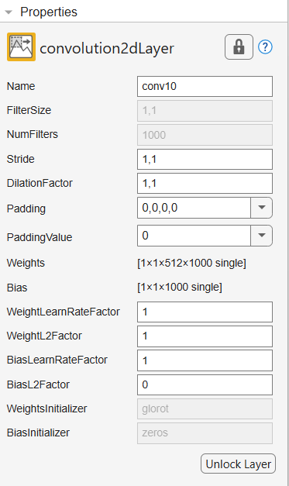
(iii) Data Pipeline and Dimensionality Alignment
Deep convolutional networks follow strict input dimensions. The SqueezeNet input layer strictly requires a spatial geometry of 227 x 227 x 3 (representing width, height, and RGB color channels). To bridge the dimensional disparity between the 500 x 500 exported spectrograms and the network input, the dataset was imported into the designer via an augmentedImageDatastore. This feature automatically down-sample the spectrogram matrices to the 227 x 227 x 3 dimensional constraint during batch processing, preventing memory overflow without permanently altering the source dataset.
(iv) Hyperparameter Tuning and Network Training
With the architecture structurally aligned, the training hyperparameters were configured. A highly constrained optimization algorithm (such as Adam) was applied, utilizing a low initial learning rate (eg. 0.0001) to facilitate gentle gradient descent. This specific restriction prevents "catastrophic forgetting," ensuring the early layers of the network retain their pre-trained feature extraction capabilities, while only the newly initialized terminal layers heavily adapt to the mechanical acoustic heat maps. Upon reaching validation convergence, the successfully adapted model was exported to the local workspace environment as the primary inference variable (trainedNetwork_1).
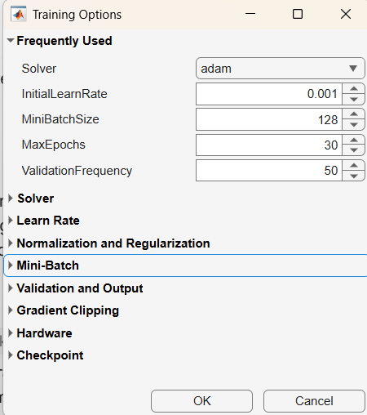 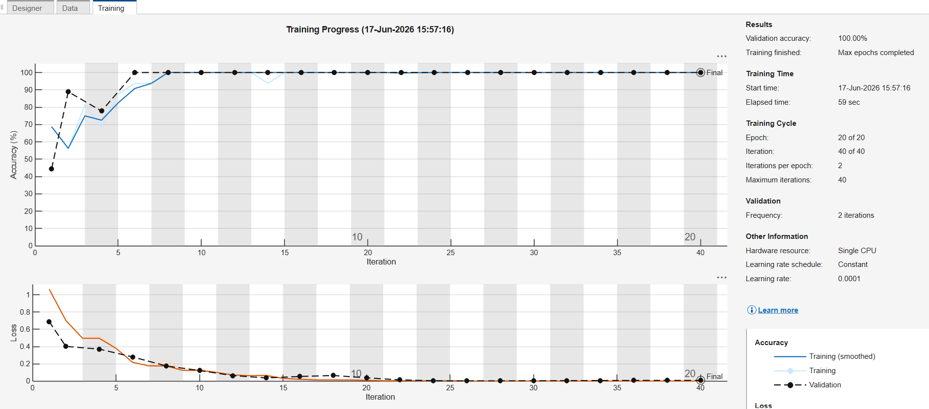
4. Model Architecture and Inference Pipeline
With the visual dataset established and the CNN architecture defined, a live inference (continuous_learning_loop.m) was developed to test unseen acoustic data against the pre-trained neural network.
- Model Ingestion
The pipeline initiates by loading the previously optimized classification model (trained_motor_model.mat) into the active workspace.
- Live Inference Translation
When a new target file (unseen_test_motor.wav) is introduced, the system performs the signal processing constraints . It generates a Mel-Spectrogram utilizing the canvas architecture, ensuring the new acoustic data is mapped identically to the training data.

- Dimensionality Matching (Trial & Error)
Because the chosen SqueezeNet-based architecture requires a strict input geometry, early runs of the inference failed due to matrix dimension mismatches. A critical modification was engineered using the imresize function, forcefully down-sampling the temporary spectrogram matrix into a strict 227 x 227 x 3 RGB format before passing it to the classify function.

- Diagnostic Dashboard
The system successfully passes the array through the CNN, extracting the highest probability and outputting a live confidence percentage and predicted mechanical state. But the confidence % for some of the heat maps were not accurate, that is the model predicted some normal spectrograms as fault ones. This is a data diversity limitation.
- Continuous Edge Learning
To elevate the system from a static into a dynamic Predictive Maintenance pipeline, a continuous learning feedback loop was created to allow the AI to adapt to mechanical wear over time.
- Experience Archiving
Upon predicting the state of a new sound anomaly, the system automatically transitions the temporary spectrogram into the permanent core training dataset. The movefile command routes the image into the respective predicted folder (Normal or Fault), appending a localized timestamp ID to prevent existing data overwriting.
- Memory Management via Datastores (Trial & Error)
When attempting to incrementally retrain the network on the newly expanded dataset, system memory overflows occurred. The solution was the implementation of an augmentedImageDatastore. This object wrapper automatically resized all historical and newly archived image matrices on-the-fly to the 227 x 227 x 3 requirement, allowing the trainNetwork function to seamlessly update the classification boundaries and resave the optimized model back to the local directory.
6.Graphical User Interface (GUI) and Live Diagnostic Dashboard
To transition the predictive maintenance system from a localized scripting environment into a deployable software tool, a standalone Graphical User Interface (GUI) was created using the MATLAB App Designer framework. This dashboard acts as the primary operational frontend, wrapping the SqueezeNet inference and Mel-Spectrogram signal processing scripts into a event-driven architecture.
(i) UI Architecture and Component Mapping
The frontend was designed to provide immediate, telemetry to the system operator without exposing the underlying computational matrix operations. The interface is composed of four primary unified components:
Live Frequency Spectrogram (app.UIAxes): A dedicated 2D Cartesian plane optimized to render the acoustic heat map in real-time, completely superseding the headless graphical exports used in earlier phases.
Execution Trigger (app.RunDiagnosisButton): The primary user input that initiates the backend acoustic capture and classification pipeline via a callback function.
AI Confidence Meter (app.AIConfidenceGauge): A radial gauge physically mapped to the maximum classification score matrix, visually quantifying the neural network's mathematical certainty bounded between 0 and 100.
System Diagnostic State (app.SystemDiagnosticstateLamp): A dynamic Boolean indicator lamp programmed to shift hexadecimal color values based on string matching from the classification output layer (e.g., transitioning to Red upon detecting a Fault anomaly).
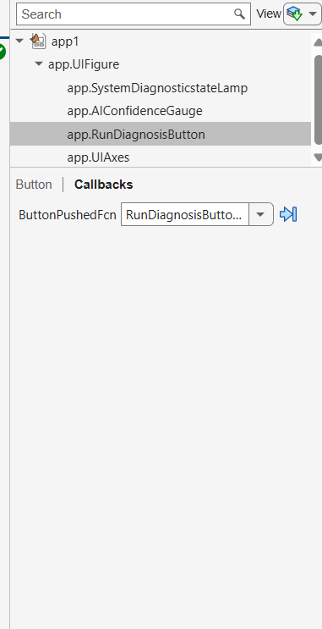

(ii) Backend Integration and Event-Driven Callbacks
Integrating the trained deep learning model into the GUI required specific memory management constraints. To prevent execution latency (UI freezing) during inference, the trained_motor_model.mat file and its associated CNN parameters are ingested into the app's private properties during the startupFcn execution. This pre-loads the SqueezeNet architecture into the system's RAM immediately upon application launch.
When the operator initiates the RunDiagnosisButtonPushed callback, the event-driven architecture executes the inference loop directly within the application shell. The incoming raw .wav temporal data is passed through the melSpectrogram function. The resulting power matrix is simultaneously routed to two distinct pathways:
Visual Routing: The matrix is converted to decibels and rendered directly onto app.UIAxes using the imagesc function and a logarithmic jet colormap.
Inference Routing: The matrix is passed through memory to be structurally resized to the 227x 227 x 3 tensor requirement.

(iii)State Execution and Output
Upon successful ingestion by the classify function, the CNN's terminal layer outputs its probability distribution vector. The callback logic extracts the maximum probabilistic integer and binds it directly to app.AIConfidenceGauge.Value. Simultaneously, conditional logic evaluates the dominant categorical string (Normal vs. Fault) and dynamically overrides the app.SystemDiagnosticstateLamp.Color property, translating complex multidimensional math into an accessible, real-world alert. Form some cases the AI confidence gauge value and diagnostic lamp were not accurate, that is some normal files were identifed as fault with 100% confidence. This can be due to direct ingestion of .wav files into model as machine learning AI model is less efficient with audio files and classification based on it.
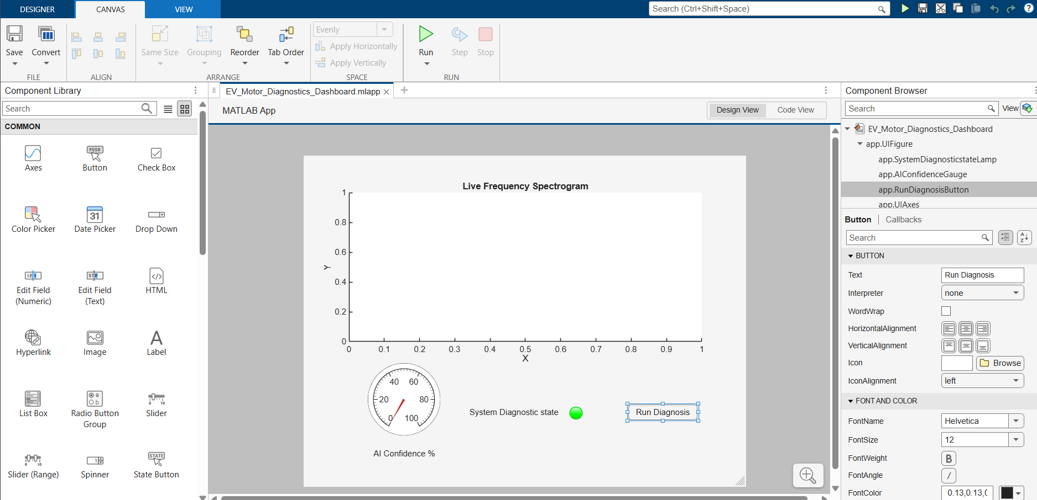

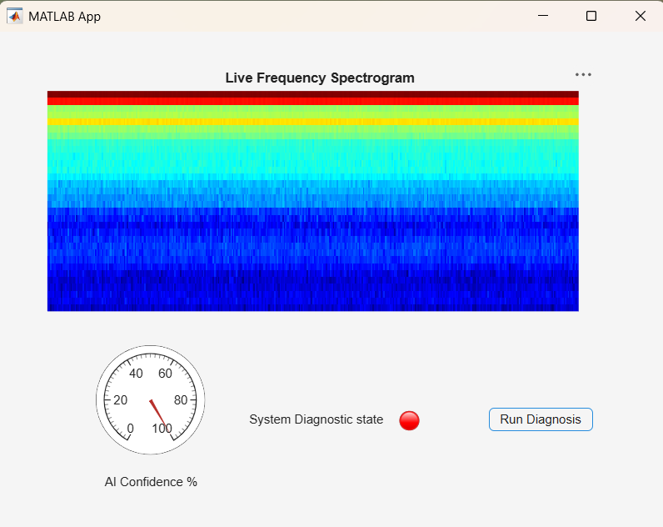

Method 2: Google Colab

1.Cloud Environment Initialization and Data Ingestion
To use cloud-based GPU acceleration for training the deep learning model, the system architecture was transitioned to Google Colab. The initial phase of this Python implementation focused on a secure, high-speed data pipeline between persistent cloud storage and the virtual machine environment.

- Cloud Storage Integration
Google Colab utilizes temporary virtual machines that are wiped after periods of inactivity, a persistent data link was required. The environment was authenticated and mounted to Google Drive using the google.colab.drive library. This established a direct bridge, allowing the Python to access the Spectrogram_Dataset.zip which contained the acoustic heat maps (spectrogram) generated during the MATLAB phase.

- Workspace Sanitization (updated version)
To ensure absolute data integrity and prevent cross-contamination from previous runtime sessions, a strict workspace clearing protocol was implemented. The bash command !rm -rf /content/dataset was executed immediately upon initialization. This forcefully deletes any residual mismatched files, guaranteeing a mathematically clean baseline state before the new data is introduced.

- I/O Latency Optimization (Extraction)

Reading hundreds of individual image files sequentially over a network connection from Google Drive introduces severe Input/Output (I/O) latency, which drastically throttles neural network training speeds. To bypass this bottleneck, the zipped dataset was decompressed (!unzip) directly into the local solid-state storage of the allocated Colab instance (/content/dataset). This architectural decision ensures the data loader can fetch training batches instantly with zero network-latency interference.

2. Directory Routing and Framework Initialization
Following the physical ingestion of the dataset into the cloud environment, the system required programmatic routing and the initialization of the deep learning backend.
- Dynamic Path Resolution
When unzipping data archives across different operating systems or cloud virtual machines, decompression behavior is often inconsistent (e.g., sometimes extracting flat files directly, and other times generating an unexpected nested parent directory). To prevent fatal FileNotFoundError exceptions during the data ingestion loop, a dynamic directory router was created using the Python os library.
The script actively queries the local directory architecture using os.listdir(). If the extraction process generated an isolated Spectrogram_Dataset sub-folder, the system anchors the DATA_DIR path directly to that nested location. This conditional logic ensures the training pipeline remains robust, self-correcting, and immune to archive formatting variations.
(ii) Deep Learning Backend Initialization
With the dataset paths strictly defined and verified, the core machine learning libraries were imported to construct the neural network environment. The system utilizes TensorFlow and its high-level neural network API, Keras, which serve as the primary mathematical execution engines for the cloud VM.

(iii) Memory Management Preparation
The explicit importation of the ImageDataGenerator class represents a critical architectural decision for resource management. Deep learning models processing 2D image matrices demand significant system memory. Rather than forcing the Google Colab to load the entire spectrogram dataset into volatile RAM simultaneously which frequently induces memory overflow crashes. This specific class prepares the system to stream, normalize, and yield the images in small, localized batches during the upcoming training phase.

3. Dataset Streaming and Augmentation Pipeline
To efficiently process the visual dataset without exceeding the memory limits of the Google Colab virtual machine, a dynamic streaming architecture was created using the Keras ImageDataGenerator class. This pipeline processes the images on-the-fly directly from the storage directory, applying real-time mathematical transformations before passing them to the neural network.
- Pixel Normalization and Feature Scaling
Deep learning models rely on gradient descent optimization, which is highly sensitive to unscaled input data. Raw RGB image pixels possess integer values ranging from 0 to 255. To stabilize the network's learning and accelerate convergence, a rescale parameter (1/255) was applied. This mathematically transforms the pixel intensities into bounded floating-point ranging between 0.0 and 1.0.
- Spatial Data Augmentation (upgraded version)
To prevent the model from simply memorizing the exact pixel coordinates of acoustic features (overfitting), dynamic spatial augmentation was introduced. The width_shift_range and height_shift_range parameters were configured to 0.05. This applies a slight 5% randomized translational shift along the X and Y axes during training. By artificially injecting this variance, the network is forced to learn translationally invariant features—meaning it learns to identify the mechanical fault signature regardless of where it appears on the spectrogram timeline.

(iii) Deterministic Batching and Train/Test Splitting
The pipeline was instructed to execute a strict 80/20 data split (validation_split=0.2), isolating 20% of the matrices for performance validation. Two independent data streams (train_generator and validation_generator) were established using the flow_from_directory function. These generators automatically down-sample the incoming spectrograms to a uniform 128x128 pixel geometry and package them into processing batches of 8 images per iteration, optimizing GPU memory utilization.

4. Upgraded Convolutional Neural Network (CNN) Architecture
With the data streaming pipeline secured, a custom Convolutional Neural Network was architected using the Keras Sequential API. This model was specifically structured to extract deep spatial hierarchies from the acoustic heat maps (spectrograms).
- Feature Extraction Layers (The Scanners)
The architecture begins with two sequential convolution blocks designed to isolate acoustic anomalies:
Layer 1 (Primitive Extraction): A Conv2D layer equipped with 16 filters and a 3x3 kernel matrix scans the 128x128x3 input to identify low-level primitives, such as hard edges and isolated acoustic peaks. This is immediately followed by a 2x2 MaxPooling2D layer, which mathematically compresses the output, discarding background data and drastically reducing the computational footprint.
Layer 2 (Complex Signature Detection): A secondary Conv2D layer utilizing 32 filters executes a deeper scan over the down-sampled data, extracting high-level, complex fault geometries (e.g., harmonic distortions and resonant friction bands). A subsequent 2x2 MaxPooling2D layer further compresses this feature map. Both convolutional layers utilize the ReLU (Rectified Linear Unit) activation function to introduce non-linearity into the network.
- Classification Head and Regularization
Following the spatial scanning blocks, the multi-dimensional feature maps are flattened into a 1D vector via the Flatten layer. This vector is passed into a Dense fully-connected layer consisting of 64 neurons (also utilizing ReLU activation), which acts as the primary decision-making matrix.
Dropout Implementation (Crucial Fix): To actively combat the "lazy guessing" phenomenon and prevent the network from over-relying on a few dominant neurons, a Dropout(0.5) layer was injected. This acts as a severe regularization mechanism, randomly disabling 50% of the interconnected neurons during each training pass. This forces the entire network architecture to learn distributed representations of the mechanical faults.
Terminal Output: The final layer is a Dense configuration with 2 neurons corresponding to the target categories (Normal and Fault). It utilizes a activation function to mathematically output a normalized binary probability distribution.

5.Neural Network Training Execution
With the CNN architecture defined and the data streaming pipeline established, the system progressed to the active training phase.
- Compilation Lock-in
Prior to execution, the model parameters were officially locked in via the compile method. The network was instructed to utilize the Adam optimizer with a learning rate of 0.001 to govern the weight-updating process. The system was programmed to evaluate its internal error using the categorical_crossentropy loss function (standard for multi-class probability outputs) while actively tracking raw accuracy as its primary human-readable metric.
- The 25-Epoch Training Loop
The mathematical learning process was initiated using the model.fit function, configured to run for exactly 25 epochs.
Batch Processing: Rather than loading the entire dataset into memory, the train_generator was utilized to feed the network the augmented 128x128 pixel matrices in highly optimized, bite-sized batches.
Simultaneous Validation: The validation_generator was integrated directly into the training loop. At the conclusion of every epoch, the network is forced to pause and classify the hidden 20% of the dataset that it has never trained on. This architecture ensures the engineering team can monitor validation loss in real-time, instantly identifying if the model begins to overfit (memorize) the training data rather than generalizing the mechanical fault patterns.
Launching 25-Epoch Training Loop...
Epoch 1/25 110/110 ━━━━━━━━━━━━━━━━━━━━ 17s 105ms/step - accuracy: 0.7680 - loss: 0.4999 - val_accuracy: 0.8165 - val_loss: 0.3335
Epoch 2/25 110/110 ━━━━━━━━━━━━━━━━━━━━ 9s 85ms/step - accuracy: 0.9486 - loss: 0.1429 - val_accuracy: 0.7936 - val_loss: 0.4435
Epoch 3/25 110/110 ━━━━━━━━━━━━━━━━━━━━ 9s 85ms/step - accuracy: 0.9646 - loss: 0.0980 - val_accuracy: 0.9954 - val_loss: 0.0336
Epoch 4/25 110/110 ━━━━━━━━━━━━━━━━━━━━ 8s 70ms/step - accuracy: 0.9817 - loss: 0.0440 - val_accuracy: 1.0000 - val_loss: 0.0236
Epoch 5/25 110/110 ━━━━━━━━━━━━━━━━━━━━ 9s 85ms/step - accuracy: 0.9863 - loss: 0.0460 - val_accuracy: 0.9817 - val_loss: 0.0463
Epoch 6/25 110/110 ━━━━━━━━━━━━━━━━━━━━ 8s 76ms/step - accuracy: 0.9794 - loss: 0.0588 - val_accuracy: 0.8670 - val_loss: 0.3592
Epoch 7/25 110/110 ━━━━━━━━━━━━━━━━━━━━ 9s 81ms/step - accuracy: 0.9806 - loss: 0.0526 - val_accuracy: 0.9908 - val_loss: 0.0431
Epoch 8/25 110/110 ━━━━━━━━━━━━━━━━━━━━ 9s 86ms/step - accuracy: 0.9874 - loss: 0.0482 - val_accuracy: 0.9954 - val_loss: 0.0276
Epoch 9/25 110/110 ━━━━━━━━━━━━━━━━━━━━ 8s 70ms/step - accuracy: 0.9874 - loss: 0.0304 - val_accuracy: 0.9908 - val_loss: 0.0242
Epoch 10/25 110/110 ━━━━━━━━━━━━━━━━━━━━ 10s 86ms/step - accuracy: 0.9931 - loss: 0.0188 - val_accuracy: 0.9404 - val_loss: 0.0998
Epoch 11/25 110/110 ━━━━━━━━━━━━━━━━━━━━ 9s 84ms/step - accuracy: 0.9909 - loss: 0.0325 - val_accuracy: 0.9817 - val_loss: 0.0530 Epoch
12/25 110/110 ━━━━━━━━━━━━━━━━━━━━ 8s 72ms/step - accuracy: 0.9874 - loss: 0.0489 - val_accuracy: 0.9954 - val_loss: 0.0177
Epoch 13/25 110/110 ━━━━━━━━━━━━━━━━━━━━ 9s 85ms/step - accuracy: 0.9909 - loss: 0.0196 - val_accuracy: 0.9862 - val_loss: 0.0327
Epoch 14/25 110/110 ━━━━━━━━━━━━━━━━━━━━ 8s 74ms/step - accuracy: 0.9977 - loss: 0.0098 - val_accuracy: 1.0000 - val_loss: 5.5450e-04
Epoch 15/25 110/110 ━━━━━━━━━━━━━━━━━━━━ 9s 84ms/step - accuracy: 0.9989 - loss: 0.0061 - val_accuracy: 1.0000 - val_loss: 0.0040
Epoch 16/25 110/110 ━━━━━━━━━━━━━━━━━━━━ 9s 86ms/step - accuracy: 0.9920 - loss: 0.0235 - val_accuracy: 0.9083 - val_loss: 0.2963
Epoch 17/25 110/110 ━━━━━━━━━━━━━━━━━━━━ 8s 71ms/step - accuracy: 0.9417 - loss: 0.1885 - val_accuracy: 0.9908 - val_loss: 0.0622
Epoch 18/25 110/110 ━━━━━━━━━━━━━━━━━━━━ 9s 85ms/step - accuracy: 0.9806 - loss: 0.0524 - val_accuracy: 1.0000 - val_loss: 0.0101
Epoch 19/25 110/110 ━━━━━━━━━━━━━━━━━━━━ 10s 86ms/step - accuracy: 0.9886 - loss: 0.0255 - val_accuracy: 0.9725 - val_loss: 0.0807
Epoch 20/25 110/110 ━━━━━━━━━━━━━━━━━━━━ 8s 70ms/step - accuracy: 0.9920 - loss: 0.0218 - val_accuracy: 1.0000 - val_loss: 0.0143
Epoch 21/25 110/110 ━━━━━━━━━━━━━━━━━━━━ 9s 86ms/step - accuracy: 0.9931 - loss: 0.0170 - val_accuracy: 1.0000 - val_loss: 0.0059
Epoch 22/25 110/110 ━━━━━━━━━━━━━━━━━━━━ 8s 74ms/step - accuracy: 0.9943 - loss: 0.0152 - val_accuracy: 1.0000 - val_loss: 0.0034
Epoch 23/25 110/110 ━━━━━━━━━━━━━━━━━━━━ 9s 81ms/step - accuracy: 0.9966 - loss: 0.0109 - val_accuracy: 1.0000 - val_loss: 0.0011
Epoch 24/25 110/110 ━━━━━━━━━━━━━━━━━━━━ 10s 90ms/step - accuracy: 0.9989 - loss: 0.0048 - val_accuracy: 1.0000 - val_loss: 6.2221e-04
Epoch 25/25 110/110 ━━━━━━━━━━━━━━━━━━━━ 8s 69ms/step - accuracy: 0.9966 - loss: 0.0051 - val_accuracy: 1.0000 - val_loss: 2.2925e-04

6. Model Serialization and Cloud-to-Local Export
Google Colab operates on volatile virtual machines; once a session times out or disconnects, all local variables and generated files are permanently destroyed. To secure the trained neural network, a export and preservation pipeline was engineered.
- HDF5 Serialization
Upon successful completion of the 25-epoch training sequence, the fully realized AI brain was serialized using the Keras save() function. The model was exported as motor_diagnostic_model.h5. The .h5 (Hierarchical Data Format version 5) extension is a highly structured file format crucial for deep learning. It does not just save the visual architecture of the network; it mathematically preserves every single trained weight, spatial bias, and the exact state of the Adam optimizer, allowing the model to be paused and resumed on entirely different hardware without retraining.
- Automated Local Hardware Transfer

To bridge the gap between the Google Colab cloud server and the physical engineering environment, the google.colab.files library was utilized. The files.download() command was programmed to automatically trigger a secure, direct download of the .h5 model file from the cloud virtual machine directly to the operator's local physical laptop. This completed the cloud phase of the project, yielding a highly accurate model ready to be integrated into local deployment dashboards or microcontroller frameworks.
7. Live Diagnostic Inference
To validate the serialized model's efficiency on unseen data, a continuous inference script was engineered directly within the Colab environment.
- System Initialization
The script verifies the presence of the uploaded .h5 file using os.path.exists() and loads the computational graph back into active memory via keras.models.load_model().
- Preprocessing & Dimensionality Alignment
When a raw target file (e.g., spec_S_IR(1937).png) is introduced, the system utilizes Keras preprocessing utilities to load and down-sample the image to the required 128 x 128 geometry. The array is mathematically normalized 255 and expanded to a 4D tensor (batch size of 1) using numpy.expand_dims to satisfy the CNN's input requirements.

- Visual Verification
A secondary visualizer utilizing matplotlib.pyplot renders the ingested spectrogram directly into the console output, allowing the engineer to visually confirm data integrity prior to algorithmic classification.
- Prediction
The model.predict() function yields a raw Softmax distribution array. Because Keras sorts categorical subsets alphanumerically during the flow_from_directory phase, array index 0 maps to Fault and index 1 maps to Normal. A conditional logic block extracts these floats, scales them to percentages, and prints an automated, stylized diagnostic report directly to the runtime console to alert the operator of the mechanical state.
Method 3: Edge Impulse
1. Introduction to the Edge AI Framework (Edge Impulse)
This method of the Predictive Maintenance System uses Edge Impulse, a specialized platform for developing TinyML (Tiny Machine Learning) applications. The objective was to translate the noise analysis methodology developed into a highly optimized, low-latency C++ library capable of executing inferences on an ESP32 microcontroller. This required building a continuous pipeline comprising data acquisition, signal processing, neural network training, live classification validation, and hardware deployment.

Data Acquisition and Dataset Balancing
The foundation of the Edge AI model was built using raw .wav acoustic files representing continuous motor operation.
- Pipeline Setup
The Data Acquisition interface was utilized as the primary ingestion pipeline, allowing raw motor sound data to be uploaded, labeled, and mathematically split into training and testing parts.
- Trial and Error (Class Imbalance)
Initially there was a class imbalance, where the Normal audio files vastly outnumbered the Fault audio files. Early training demonstrated that this imbalance caused the AI to adopt a "guessing" strategy, reducing its accuracy by simply defaulting to the majority class to minimize loss artificially.

- Methodological Correction
Then the dataset was strictly balanced by auditing the data and uploading an exact equal amount of audio files for both classes. A randomized Train/Test split of 80/20 was subsequently applied, forcing the neural network to analyze the mathematical acoustic differences rather than relying on statistical probability.

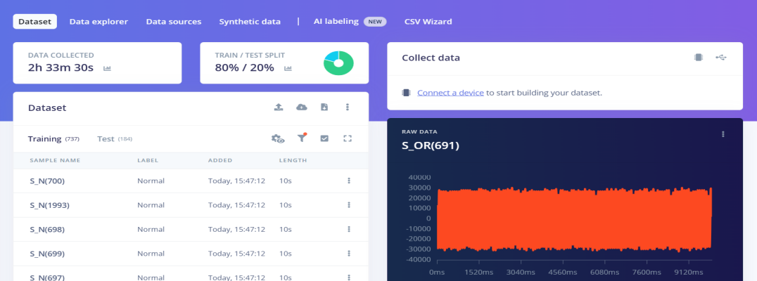

3. Impulse Design and Signal Preprocessing
The Impulse Design interface acts as the architectural blueprint of the Edge AI model, defining how raw time-series data is filtered and passed to the learning blocks.
- Time series data management
The time-series data was segmented using a 1000 ms window size with a 500 ms window increase. This creates a 50% overlapping duty cycle, ensuring that transient acoustic anomalies occurring exactly at the frame boundaries are not missed during transition periods.The "Zero-pad data" feature was considered for handling audio files shorter than the 1000 ms.
- Feature Extraction (MFE vs. Spectrogram)
A standard Spectrogram maps linear frequency intensities over time, it is largely optimized for human speech. For mechanical applications, Mel-Filterbank Energy (MFE) is efficient. MFE excels at isolating continuous, non-voice mechanical acoustics; it filters out background environmental noise while heavily amplifying the high-frequency clicking and grinding sounds indicative of faults.
The MFE mathematical parameters (frame length, filter banks, and FFT size) were dynamically optimized using the platform's Autotune feature, establishing specific frequency boundaries modified to the motor's operating RPM.
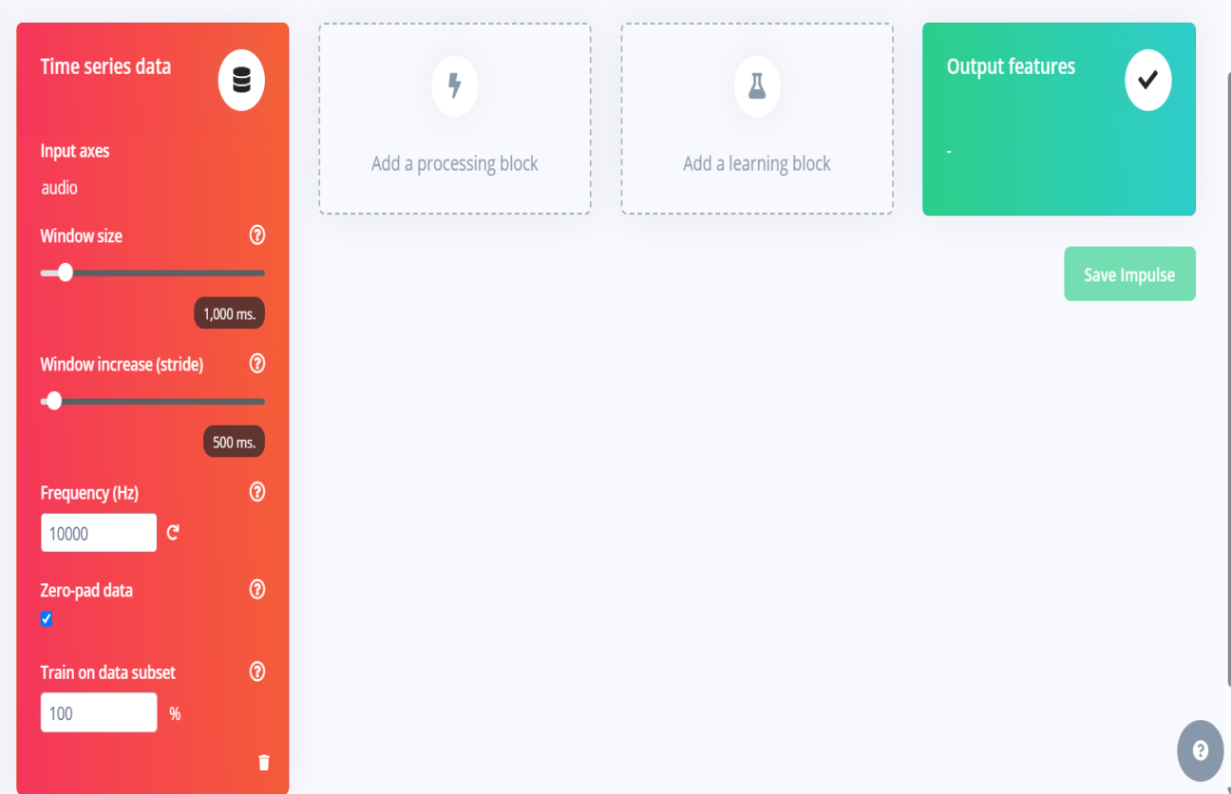

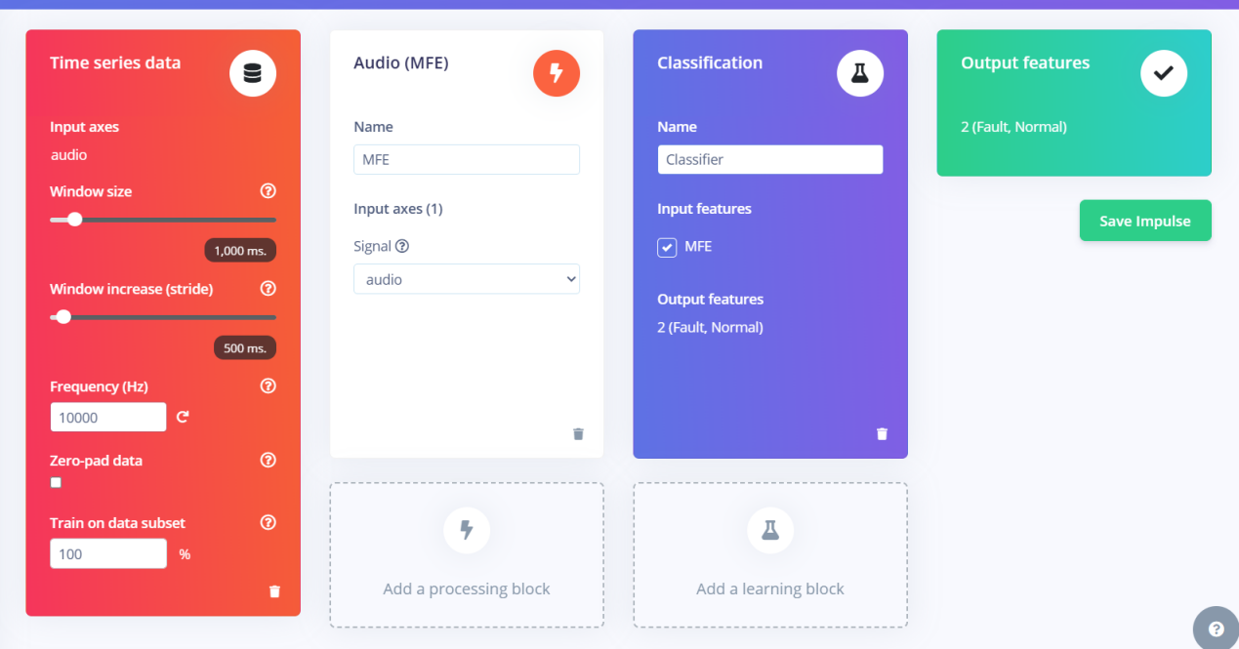

4. Neural Network Architecture and Training Iterations
The Classifier block defines the deep learning architecture responsible for analyzing the generated MFE feature maps and identifying fault patterns.
- Trial and Error (Parameters and features)
Initially the default parameters were used for mel energies and FFT output, but the differences between normal and fault was less accurate in feature explorer. Then the MFE mathematical parameters (frame length, filter banks, and FFT size) were dynamically optimized using the platform's Autotune feature, establishing specific frequency boundaries modified to the motor's operating RPM.
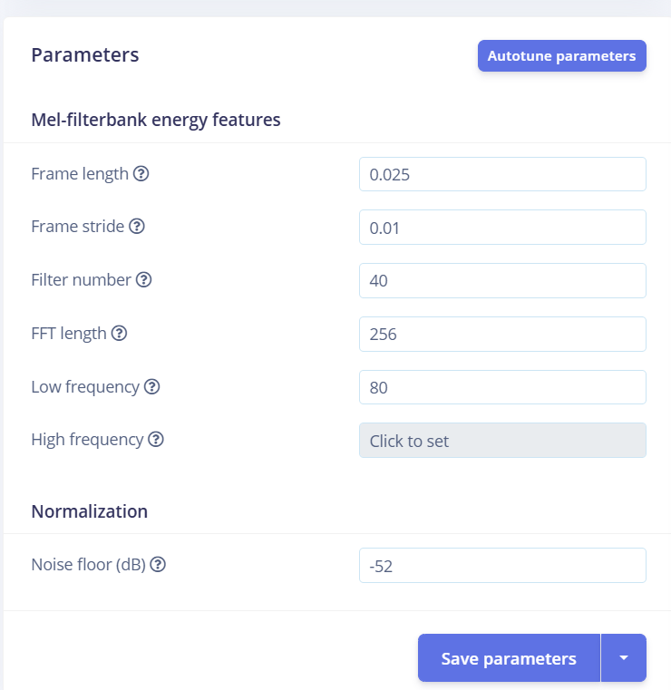

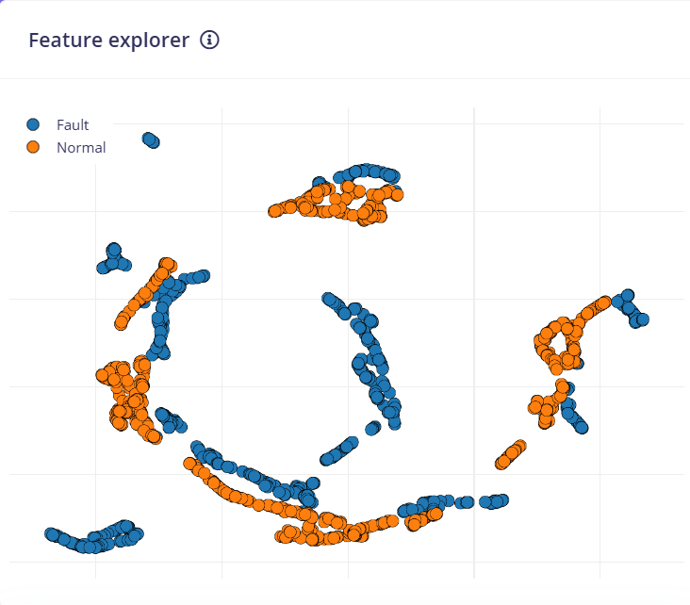

- Trial and Error (classification)
Classifier uses the neural network to make the model accurate and differentiate between normal and fault. Initially the neural network settings were - number of training cycles (50), learning rate (0.005), training processor (CPU) and 1D CNN. These settings did not produce the required result where there was a change in confusion matrix and some loss was noted. To overcome this the neural network settings were changed to 75, 0.005, GPU and 2D CNN respectively. This made the architecture completely reset and upgraded to a 2D Convolutional Network (2D CNN) which captures structural mechanical changes perfectly.
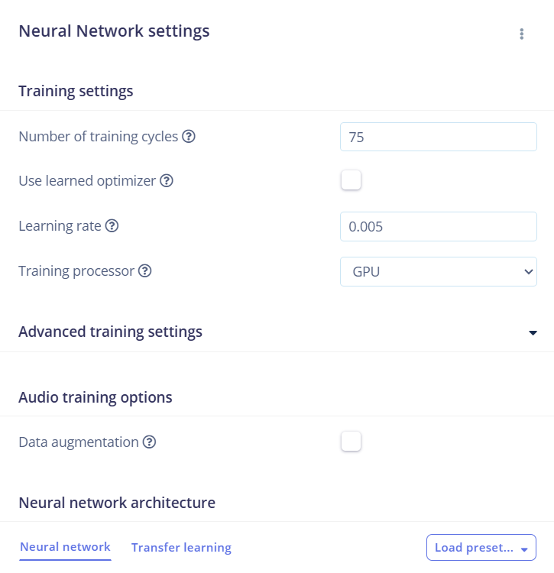

- Training Results
The model was trained over 75 epochs and optimized 2D architecture broke the flatline bottleneck, achieving a flawless 100% validation accuracy and a 0.00 loss score during internal evaluation.

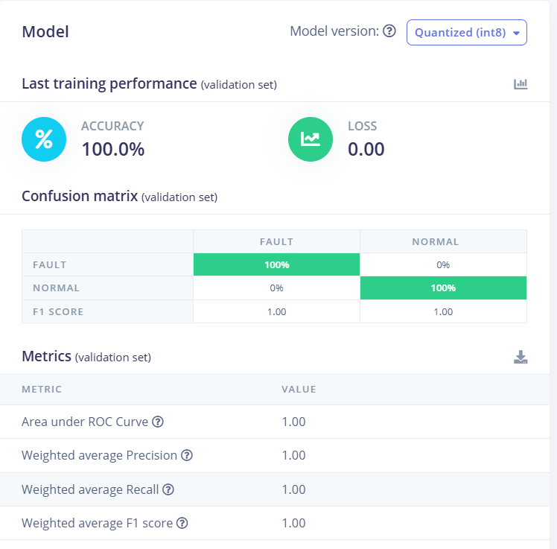
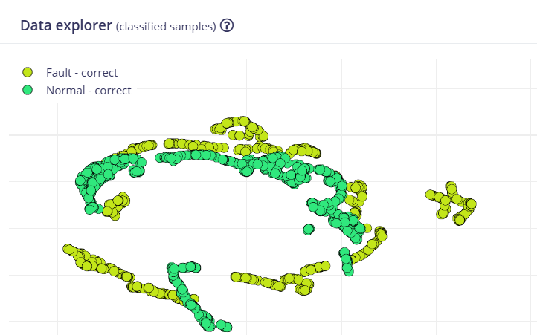

5.Model Testing and Live Classification Validation
To ensure the model possessed generalized learning rather than memorized overfitting, independent validation tools were utilized. The trained network was evaluated against the untouched 20% of the dataset reserved during the initial split. The model achieved 100% accuracy on this unseen data, validating the reliability of the MFE and 2D CNN combination. In the initial stages when a new file is tested, sometimes a normal file is classified as fault. To overcome this limitation 1000 files from each category was acquired and the training process was repeated. This made the accuracy better along with proper identification.
This trained model can then be quantized to 8-bit for the complex 2D CNN to work efficiently on ESP32. This is a crucial step for TinyML and system is compiled and imported as arduino library (zip file) which is then used in Arduino IDE to interface with the microcontroller in the hardware prototype.

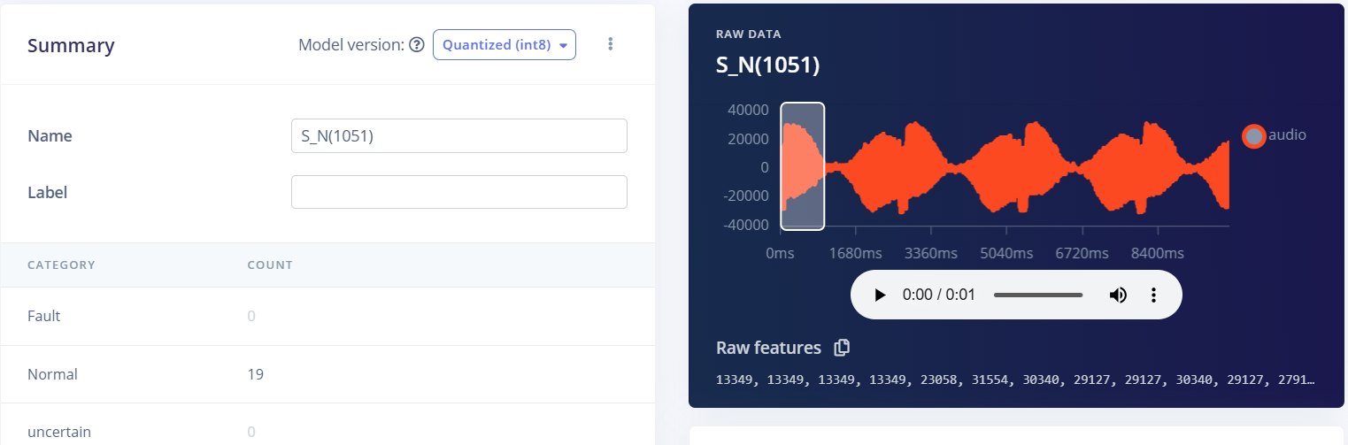

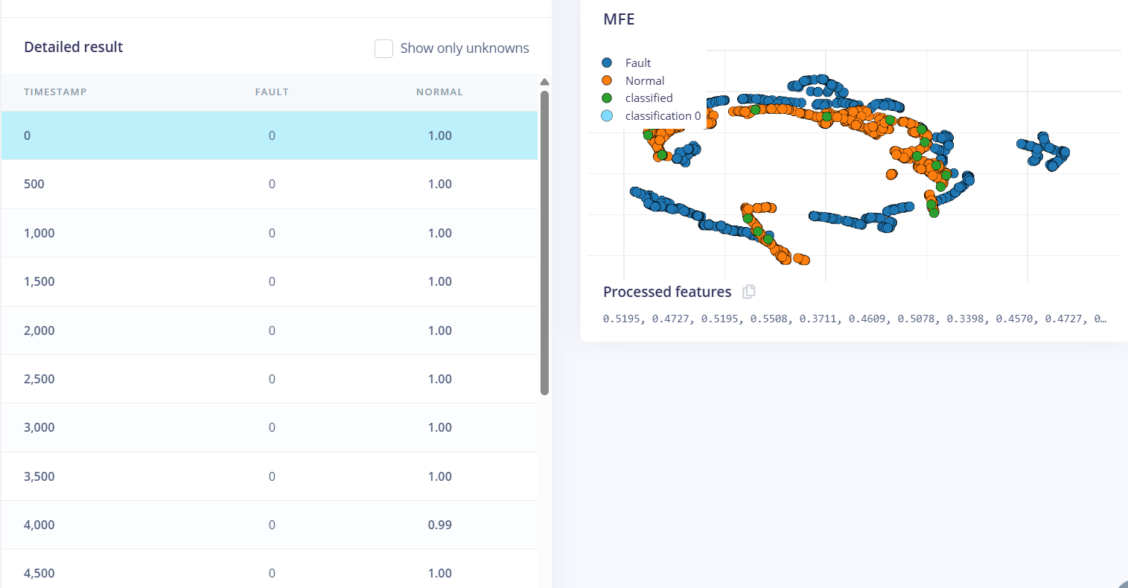

1. Initial Objective
Our primary goal was to build an intelligent, low-cost predictive maintenance system that can "listen" to an industrial motor and automatically detect early-stage bearing faults before a catastrophic breakdown occurs. Instead of relying on traditional schedule-based maintenance (like replacing parts every 6 months regardless of condition), we wanted to create a real-time, data-driven system that alerts engineers the exact moment a mechanical anomaly starts developing.

2. Initial Assumptions
Before we began building and testing, we made a few core assumptions:
Simple Data Processing: We assumed that raw 1D audio and vibration waveforms could be fed directly into a basic AI model without needing complex preprocessing.
Model Simplicity: We assumed a simple 1D neural network or a basic Dense (fully connected) model would be enough to learn and distinguish between healthy motor humming and faulty clicking.
Equal Fault Visibility: We assumed that all types of bearing faults (whether on the inner race or outer race) would sound equally loud and distinct to the microphone.

3. How Did We Test Our Assumptions
We put our assumptions to the test through a trial-and-error methodology across three different environments (MATLAB, Google Colab, and Edge Impulse).
Data Transformation Tests: We compared feeding raw 1D sound waves against converting the audio into 2D visual heat maps (Mel-Spectrograms and Mel-Filterbank Energy / MFE).
Model Architecture Trials: We built and trained multiple AI architectures—starting from simple Dense networks up to advanced 2D Convolutional Neural Networks (CNNs) and transfer learning models (SqueezeNet).
Real-World Validation: We tested our trained models against completely unseen audio files, specifically checking how the AI performed when listening to muffled internal damages (like Inner Race faults) versus loud external damages.

4. Among the 3 Approaches, Which Worked Best (and Why)
During our project, we explored three distinct deployment approaches
MATLAB App Designer (Desktop GUI with SqueezeNet Transfer Learning)
Google Colab (Cloud-based custom 2D CNN in Python/Keras)
Edge Impulse / TinyML (Microcontroller-based 2D CNN with int8 Quantization)
While MATLAB and Colab were excellent for deep analysis and visualizing our data, Approach 3 (Edge Impulse TinyML) worked best for our final real-world engineering goal due to following reasons:
Zero Cloud Latency: In a factory, you cannot always rely on internet connectivity. The Edge Impulse model runs entirely offline on a small, low-power microcontroller (like an ESP32) right next to the motor.
Incredible Efficiency: By using int8 quantization, we compressed our complex 2D AI brain by roughly 4x. It ran fast on bare-metal hardware while still achieving 100% accuracy on our validation tests.
Purpose-Built Filtering: The Mel-Filterbank Energy (MFE) preprocessing block did the best job of cutting through background factory noise while amplifying high-frequency mechanical grinding.

5. What Do We Conclude at This Stage
2D Vision beats 1D Sound: We concluded that machine learning models struggle with raw sound waves. Translating audio into visual heat maps (Spectrograms/MFE) and using a 2D Convolutional Neural Network is by far the most reliable way to catch mechanical faults.
Edge AI is Viable for Industry: We proved that you do not need expensive supercomputers or massive cloud servers to do industrial predictive maintenance. Microcontrollers running optimized TinyML models can monitor machinery locally, safely, and accurately.
Continuous Learning is Essential: To prevent blind spots (like the AI initially missing muffled inner-race faults), an engineering system must have a continuous feedback loop where newly discovered fault patterns are archived and used to retrain the model over time.

- What is Interesting to Explore Further
- Hardware Ruggedization Testing: Physically building and testing our proposed PEEK polymer enclosure and ePTFE (Gore-Tex) acoustic vent membranes in an actual high-temperature, oily factory environment to verify long-term durability.

- Energy-Saving Duty Cycling: To make the device completely self-sustaining for long-term industrial use, we will implement an smart power-saving duty cycle. Instead of running continuous 24/7 inference which drains battery and generates excess chip heat the microcontroller will stay in a low-power mode and only wake up periodically (for example after the vehicle travels for 500km) to listen to the motor, log data, and go back to sleep.
(iii)5-Stage Degradation Prediction:
We are implementing this 5-stage sequential prediction pipeline to move beyond basic alerts and provide a complete, evolving timeline of machine health. Industrial motor failures do not happen overnight; they develop progressively over time. This progressive tracking gives maintenance teams maximum lead time to order spare parts, schedule targeted downtime, and intervene long before a minor defect turns into a catastrophic breakdown.
Stage 1 (Healthy Operation)
Stage 2 (Early Inception / Low Wear)
Stage 3 (Imminent Fault Detection - Alert Mode Begins)
Stage 4 (Advanced Degradation - Critical Alert Mode)
Stage 5 (Catastrophic Threshold - Emergency Shutdown Alert)

Submitted by :
- Harish
2nd year ECE
VIT Chennai

